# Screenshots of Application:

Search for Court Case(s):

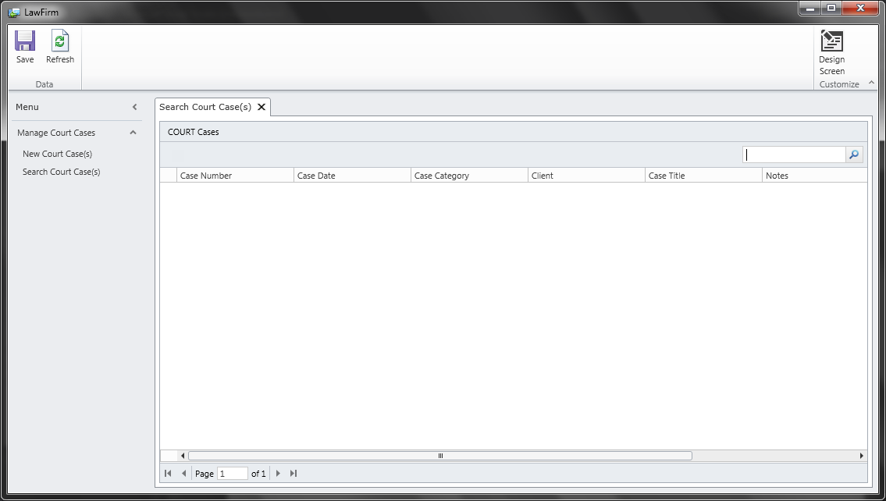

Add New Court Case(s):

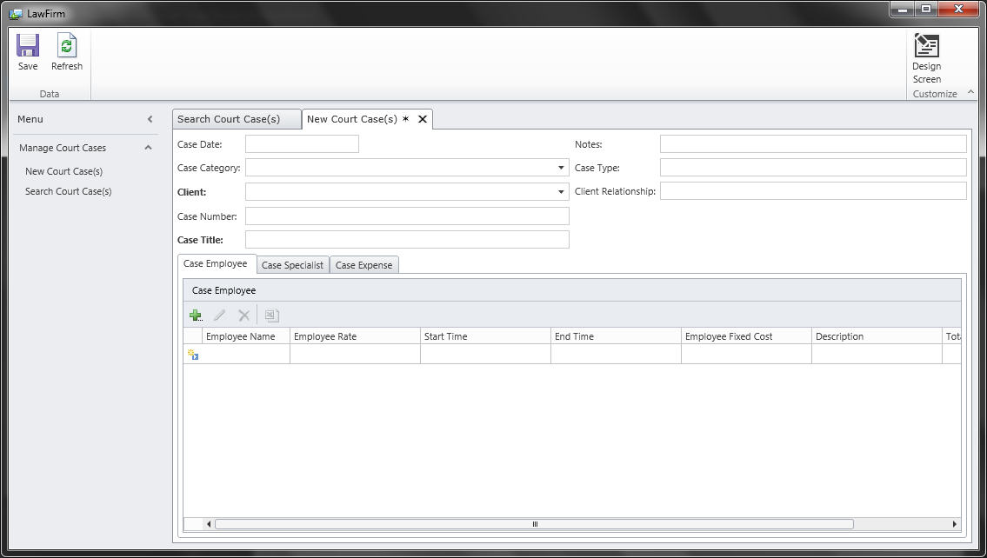

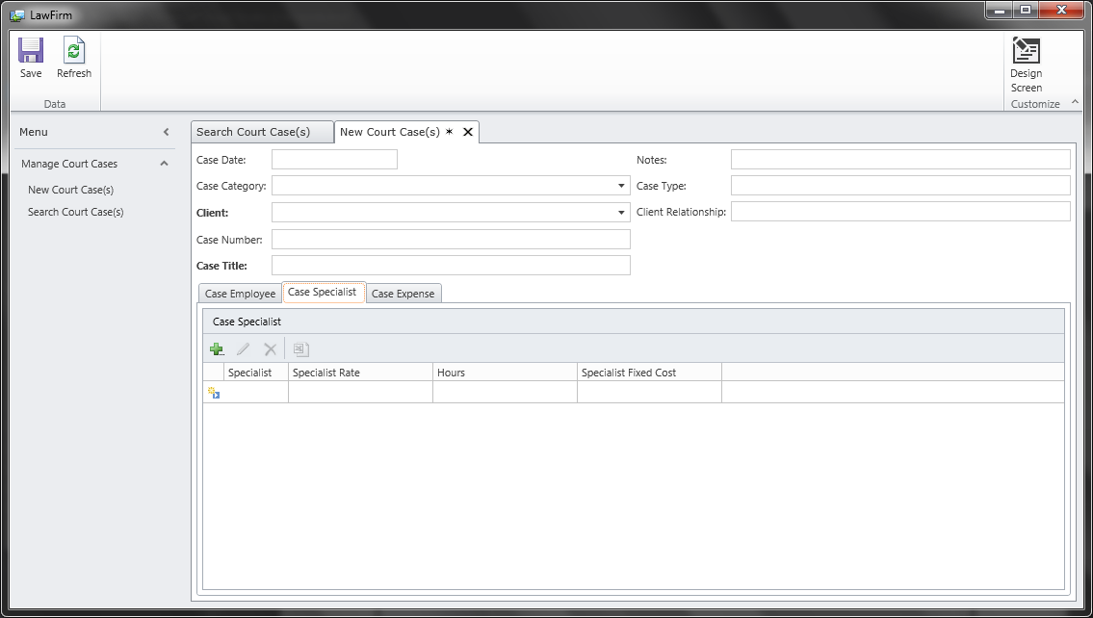

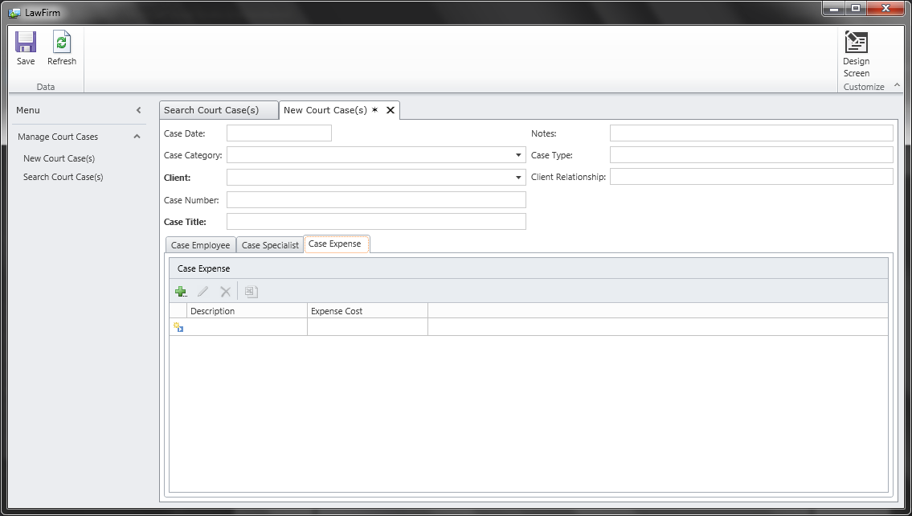

# Database Scripts:

Table CASE_EMPLOYEE:

USE [LawFirmDRM22]

GO

/****** Object: Table [dbo].[CASE_EMPLOYEE] Script Date: 9/21/2012 8:35:17 PM ******/

SET ANSI_NULLS ON

GO

SET QUOTED_IDENTIFIER ON

GO

CREATE TABLE [dbo].[CASE_EMPLOYEE](

[case_emp_ID][int]IDENTITY(1,1) NOT NULL,

[case_ID] [int] NOT NULL,

[employee_ID] [int] NOT NULL,

[employee_rate] [money] NULL,

[Description][nvarchar](255) NULL,

[START_TIME][datetime] NULL,

[END_TIME][datetime] NULL,

[HOURS_WORKED][decimal](5,2) NULL,

[EMPLOYEE_FIXED_COST][money] NULL

CONSTRAINT [PK_CASE_EMP_ID] PRIMARY KEY CLUSTERED

(

[case_emp_ID] ASC

)WITH (PAD_INDEX = OFF, STATISTICS_NORECOMPUTE = OFF, IGNORE_DUP_KEY = OFF, ALLOW_ROW_LOCKS = ON, ALLOW_PAGE_LOCKS = ON) ON [PRIMARY]

) ON [PRIMARY]

GO

ALTER TABLE [dbo].[CASE_EMPLOYEE] WITH CHECK ADD CONSTRAINT [FK_CASE_ID] FOREIGN KEY([case_ID])

REFERENCES [dbo].[COURT_CASE] ([case_ID]) on delete cascade

GO

ALTER TABLE [dbo].[CASE_EMPLOYEE] CHECK CONSTRAINT [FK_CASE_ID]

GO

ALTER TABLE [dbo].[CASE_EMPLOYEE] WITH CHECK ADD CONSTRAINT [FK_EMPLOYEE_ID] FOREIGN KEY([employee_ID])

REFERENCES [dbo].[EMPLOYEES] ([employee_ID]) on delete cascade

GO

ALTER TABLE [dbo].[CASE_EMPLOYEE] CHECK CONSTRAINT [FK_EMPLOYEE_ID]

GO

Table CASE_EXPENSES:

USE [LawFirmDRM2]

GO

/****** Object: Table [dbo].[CASE_EXPENSE] Script Date: 9/21/2012 8:41:27 PM ******/

SET ANSI_NULLS ON

GO

SET QUOTED_IDENTIFIER ON

GO

CREATE TABLE [dbo].[CASE_EXPENSE](

[case_exp_ID][int] IDENTITY(1,1) NOT NULL,

[case_ID] [int] NOT NULL,

[description][nvarchar](255),

[expense_cost] [money] NULL,

CONSTRAINT [PK_CASE_EXP_ID] PRIMARY KEY CLUSTERED

(

[case_exp_ID] ASC

)WITH (PAD_INDEX = OFF, STATISTICS_NORECOMPUTE = OFF, IGNORE_DUP_KEY = OFF, ALLOW_ROW_LOCKS = ON, ALLOW_PAGE_LOCKS = ON) ON [PRIMARY]

) ON [PRIMARY]

GO

ALTER TABLE [dbo].[CASE_EXPENSE] WITH CHECK ADD CONSTRAINT [FK_CASE_ID3] FOREIGN KEY([case_ID])

REFERENCES [dbo].[COURT_CASE] ([case_ID]) on delete cascade

GO

ALTER TABLE [dbo].[CASE_EXPENSE] CHECK CONSTRAINT [FK_CASE_ID3]

GO

Table CASE_SPECIALIST:

USE [LawFirmDRM2]

GO

/****** Object: Table [dbo].[CASE_SPECIALIST] Script Date: 9/21/2012 8:38:22 PM ******/

SET ANSI_NULLS ON

GO

SET QUOTED_IDENTIFIER ON

GO

CREATE TABLE [dbo].[CASE_SPECIALIST](

[case_spec_ID][int] IDENTITY(1,1) NOT NULL,

[case_ID] [int] NOT NULL,

[specialist_ID] [int] NOT NULL,

[specialist_rate] [money] NULL,

[hours][int],

[SPECIALIST_FIXED_COST][money]

CONSTRAINT [PK_CASE_SP_ID] PRIMARY KEY CLUSTERED

(

[case_spec_ID] ASC

)WITH (PAD_INDEX = OFF, STATISTICS_NORECOMPUTE = OFF, IGNORE_DUP_KEY = OFF, ALLOW_ROW_LOCKS = ON, ALLOW_PAGE_LOCKS = ON) ON [PRIMARY]

) ON [PRIMARY]

GO

ALTER TABLE [dbo].[CASE_SPECIALIST] WITH CHECK ADD CONSTRAINT [FK_CASE_ID2] FOREIGN KEY([case_ID])

REFERENCES [dbo].[COURT_CASE] ([case_ID]) on delete cascade

GO

ALTER TABLE [dbo].[CASE_SPECIALIST] CHECK CONSTRAINT [FK_CASE_ID2]

GO

ALTER TABLE [dbo].[CASE_SPECIALIST] WITH CHECK ADD CONSTRAINT [FK_SP_ID2] FOREIGN KEY([specialist_ID])

REFERENCES [dbo].[SPECIALISTS] ([specialist_ID]) on delete cascade

GO

ALTER TABLE [dbo].[CASE_SPECIALIST] CHECK CONSTRAINT [FK_SP_ID2]

GO

Table CASE_TYPE:

USE [LawFirmDRM2]

GO

/****** Object: Table [dbo].[CASE_TYPE] Script Date: 9/21/2012 8:18:47 PM ******/

SET ANSI_NULLS ON

GO

SET QUOTED_IDENTIFIER ON

GO

CREATE TABLE [dbo].[CASE_TYPE](

[case_category_ID] [int] IDENTITY(1,1) NOT NULL,

[case_catagory] [nvarchar](255) NOT NULL,

[title] [nvarchar](255) NULL,

[amount] [money]

CONSTRAINT [PK_CASE_CAT_ID] PRIMARY KEY CLUSTERED

(

[case_category_ID] ASC

)WITH (PAD_INDEX = OFF, STATISTICS_NORECOMPUTE = OFF, IGNORE_DUP_KEY = OFF, ALLOW_ROW_LOCKS = ON, ALLOW_PAGE_LOCKS = ON) ON [PRIMARY]

) ON [PRIMARY]

GO

Table CLIENT_RELATIONSHIP:

USE [LawFirmDRM2]

GO

/****** Object: Table [dbo].[CLIENT_RELATIONSHIP] Script Date: 10/8/2012 12:02:25 PM ******/

SET ANSI_NULLS ON

GO

SET QUOTED_IDENTIFIER ON

GO

CREATE TABLE [dbo].[CLIENT_RELATIONSHIP](

[CLIENT_RELA_ID] [int] IDENTITY(1,1) NOT NULL,

[CLIENT_RELATIONSHIP] [nvarchar](255) NULL,

CONSTRAINT [PK_CLIENT_RELA_ID] PRIMARY KEY CLUSTERED

(

[CLIENT_RELA_ID] ASC

)WITH (PAD_INDEX = OFF, STATISTICS_NORECOMPUTE = OFF, IGNORE_DUP_KEY = OFF, ALLOW_ROW_LOCKS = ON, ALLOW_PAGE_LOCKS = ON) ON [PRIMARY]

) ON [PRIMARY]

GO

Table CLIENT_STATUS:

USE [LawFirmDRM2]

GO

/****** Object: Table [dbo].[CLIENT_STATUS] Script Date: 9/21/2012 8:13:28 PM ******/

SET ANSI_NULLS ON

GO

SET QUOTED_IDENTIFIER ON

GO

CREATE TABLE [dbo].[CLIENT_STATUS](

[client_status_ID] [int] IDENTITY(1,1) NOT NULL,

[client_status] [nvarchar](25) NOT NULL,

CONSTRAINT [PK_CLIENT_STATUS_ID] PRIMARY KEY CLUSTERED

(

[client_status_ID] ASC

)WITH (PAD_INDEX = OFF, STATISTICS_NORECOMPUTE = OFF, IGNORE_DUP_KEY = OFF, ALLOW_ROW_LOCKS = ON, ALLOW_PAGE_LOCKS = ON) ON [PRIMARY]

) ON [PRIMARY]

GO

Table CLIENT_SUFFIX:

USE [LawFirmDRM2]

GO

/****** Object: Table [dbo].[CLIENT_SUFFIX] Script Date: 9/21/2012 8:15:52 PM ******/

SET ANSI_NULLS ON

GO

SET QUOTED_IDENTIFIER ON

GO

CREATE TABLE [dbo].[CLIENT_SUFFIX](

[client_suffix_ID] [int] IDENTITY(1,1) NOT NULL,

[client_suffix] [nvarchar](25) NOT NULL,

CONSTRAINT [PK_CLIENT_SUFFIX_ID] PRIMARY KEY CLUSTERED

(

[client_suffix_ID] ASC

)WITH (PAD_INDEX = OFF, STATISTICS_NORECOMPUTE = OFF, IGNORE_DUP_KEY = OFF, ALLOW_ROW_LOCKS = ON, ALLOW_PAGE_LOCKS = ON) ON [PRIMARY]

) ON [PRIMARY]

GO

Table CLIENTS:

USE [LawFirmDRM2]

GO

/****** Object: Table [dbo].[CLIENTS] Script Date: 9/21/2012 8:23:26 PM ******/

SET ANSI_NULLS ON

GO

SET QUOTED_IDENTIFIER ON

GO

CREATE TABLE [dbo].[CLIENTS](

[client_ID] [int] IDENTITY(1,1) NOT NULL,

[client_status_ID] [int] NOT NULL,

[app_ret_date][datetime] NOT NULL,

[client_suffix_ID] [int] NOT NULL,

[first_name] [nvarchar](255) NOT NULL,

[last_name][nvarchar](255) NOT NULL,

[DOB][datetime],

[STREET_ADDRESS][nvarchar](255),

[CITY][varchar](100) ,

[STATE][char](2),

[ZIP][int] ,

[JID_CDC][nvarchar](100),

[SSN][int],

[DRIVER_LICENSE][nvarchar](25),

[EMAIL][nvarchar](50),

[PHONE][nvarchar](20)

CONSTRAINT [PK_CLIENT_ID] PRIMARY KEY CLUSTERED

(

[client_ID] ASC

)WITH (PAD_INDEX = OFF, STATISTICS_NORECOMPUTE = OFF, IGNORE_DUP_KEY = OFF, ALLOW_ROW_LOCKS = ON, ALLOW_PAGE_LOCKS = ON) ON [PRIMARY]

) ON [PRIMARY]

GO

ALTER TABLE [dbo].[CLIENTS] WITH CHECK ADD CONSTRAINT [FK_CLIENT_STATUS_ID] FOREIGN KEY([client_status_ID])

REFERENCES [dbo].[CLIENT_STATUS] ([client_status_ID])

GO

ALTER TABLE [dbo].[CLIENTS] CHECK CONSTRAINT [FK_CLIENT_STATUS_ID]

GO

ALTER TABLE [dbo].[CLIENTS] WITH CHECK ADD CONSTRAINT [FK_CLIENT_SUFFIX_ID] FOREIGN KEY([client_suffix_ID])

REFERENCES [dbo].[CLIENT_SUFFIX] ([client_suffix_ID])

GO

ALTER TABLE [dbo].[CLIENTS] CHECK CONSTRAINT [FK_CLIENT_SUFFIX_ID]

GO

Table COURT_CASE:

USE [LawFirmDRM2]

GO

/****** Object: Table [dbo].[COURT_CASE] Script Date: 9/21/2012 8:30:14 PM ******/

SET ANSI_NULLS ON

GO

SET QUOTED_IDENTIFIER ON

GO

CREATE TABLE [dbo].[COURT_CASE](

[case_ID] [int] IDENTITY(1,1) NOT NULL,

[case_number][varchar](255),

[case_category_ID] [int] NULL,

[client_ID] [int] NOT NULL,

[case_type][nvarchar](255) NULL,

[case_title] [nvarchar](255) NOT NULL,

[case_date] [datetime] NULL,

[client_relationship] [nvarchar](255) NULL,

[notes][nvarchar](255) NULL,

CONSTRAINT [PK_CASE_ID] PRIMARY KEY CLUSTERED

(

[case_ID] ASC

)WITH (PAD_INDEX = OFF, STATISTICS_NORECOMPUTE = OFF, IGNORE_DUP_KEY = OFF, ALLOW_ROW_LOCKS = ON, ALLOW_PAGE_LOCKS = ON) ON [PRIMARY]

) ON [PRIMARY]

GO

ALTER TABLE [dbo].[COURT_CASE] WITH CHECK ADD CONSTRAINT [FK_CASE_CAT_ID] FOREIGN KEY([case_category_ID])

REFERENCES [dbo].[CASE_TYPE] ([case_category_ID])

GO

ALTER TABLE [dbo].[COURT_CASE] CHECK CONSTRAINT [FK_CASE_CAT_ID]

GO

ALTER TABLE [dbo].[COURT_CASE] WITH CHECK ADD CONSTRAINT [FK_CLIENT_ID] FOREIGN KEY([client_ID])

REFERENCES [dbo].[CLIENTS] ([client_ID])

GO

ALTER TABLE [dbo].[COURT_CASE] CHECK CONSTRAINT [FK_CLIENT_ID]

GO

Table EMPLOYEE_TYPE:

USE [LawFirmDRM2

GO

/****** Object: Table [dbo].[EMPLOYEE_TYPE] Script Date: 9/21/2012 8:17:16 PM ******/

SET ANSI_NULLS ON

GO

SET QUOTED_IDENTIFIER ON

GO

CREATE TABLE [dbo].[EMPLOYEE_TYPE](

[employee_type_ID] [int] IDENTITY(1,1) NOT NULL,

[employee_type] [nvarchar](255) NULL,

CONSTRAINT [PK_EMPLYEE_TYPE_ID] PRIMARY KEY CLUSTERED

(

[employee_type_ID] ASC

)WITH (PAD_INDEX = OFF, STATISTICS_NORECOMPUTE = OFF, IGNORE_DUP_KEY = OFF, ALLOW_ROW_LOCKS = ON, ALLOW_PAGE_LOCKS = ON) ON [PRIMARY]

) ON [PRIMARY]

GO

Table EMPLOYEES:

USE [LawFirmDRM2]

GO

/****** Object: Table [dbo].[EMPLOYEES] Script Date: 9/21/2012 8:27:58 PM ******/

SET ANSI_NULLS ON

GO

SET QUOTED_IDENTIFIER ON

GO

CREATE TABLE [dbo].[EMPLOYEES](

[employee_ID] [int] IDENTITY(1,1) NOT NULL,

[employee_type_ID] [int] NULL,

[first_name] [nvarchar](255) NOT NULL,

[last_name][nvarchar](255) NOT NULL,

[DOB][datetime],

[STREET_ADDRESS][nvarchar](255),

[CITY][varchar](100) ,

[STATE][char](2),

[ZIP][int],

[EMAIL][nvarchar](50),

[PHONE][nvarchar](20)

CONSTRAINT [PK_EMPLOYEE_ID] PRIMARY KEY CLUSTERED

(

[employee_ID] ASC

)WITH (PAD_INDEX = OFF, STATISTICS_NORECOMPUTE = OFF, IGNORE_DUP_KEY = OFF, ALLOW_ROW_LOCKS = ON, ALLOW_PAGE_LOCKS = ON) ON [PRIMARY]

) ON [PRIMARY]

GO

ALTER TABLE [dbo].[EMPLOYEES] WITH CHECK ADD CONSTRAINT [FK_EMPLYEE_TYPE_ID] FOREIGN KEY([employee_type_ID])

REFERENCES [dbo].[EMPLOYEE_TYPE] ([employee_type_ID])

GO

ALTER TABLE [dbo].[EMPLOYEES] CHECK CONSTRAINT [FK_EMPLYEE_TYPE_ID]

GO

Table EXPENSE_TYPE:

USE [LawFirm]

GO

/****** Object: Table [dbo].[EXPENSE_TYPE] Script Date: 9/21/2012 8:22:31 PM ******/

SET ANSI_NULLS ON

GO

SET QUOTED_IDENTIFIER ON

GO

CREATE TABLE [dbo].[EXPENSE_TYPE](

[expense_type_ID] [int] IDENTITY(1,1) NOT NULL,

[expense_type] [nvarchar](255) NULL,

CONSTRAINT [PK_EXP_TYPE_ID] PRIMARY KEY CLUSTERED

(

[expense_type_ID] ASC

)WITH (PAD_INDEX = OFF, STATISTICS_NORECOMPUTE = OFF, IGNORE_DUP_KEY = OFF, ALLOW_ROW_LOCKS = ON, ALLOW_PAGE_LOCKS = ON) ON [PRIMARY]

) ON [PRIMARY]

GO

Table SPECIALIST_TYPE:

USE [LawFirmDRM2]

GO

/****** Object: Table [dbo].SPECIALIST_TYPE] Script Date: 9/21/2012 8:22:31 PM ******/

SET ANSI_NULLS ON

GO

SET QUOTED_IDENTIFIER ON

GO

CREATE TABLE [dbo].[SPECIALIST_TYPE](

[SPECIALIST_type_ID] [int] IDENTITY(1,1) NOT NULL,

[SPECIALIST_type] [nvarchar](255) NULL,

CONSTRAINT [PK_SP_TYPE_ID] PRIMARY KEY CLUSTERED

(

[SPECIALIST_type_ID] ASC

)WITH (PAD_INDEX = OFF, STATISTICS_NORECOMPUTE = OFF, IGNORE_DUP_KEY = OFF, ALLOW_ROW_LOCKS = ON, ALLOW_PAGE_LOCKS = ON) ON [PRIMARY]

) ON [PRIMARY]

GO

Table SPECIALIST:

USE [LawFirmDRM2]

GO

/****** Object: Table [dbo].[SPECIALISTS] Script Date: 9/21/2012 8:33:59 PM ******/

SET ANSI_NULLS ON

GO

SET QUOTED_IDENTIFIER ON

GO

CREATE TABLE [dbo].[SPECIALISTS](

[specialist_ID] [int] IDENTITY(1,1) NOT NULL,

[specialist_type_ID] [int] NULL,

[first_name] [nvarchar](255) NOT NULL,

[last_name][nvarchar](255) NOT NULL,

[DOB][datetime],

[STREET_ADDRESS][nvarchar](255),

[CITY][varchar](100) ,

[STATE][char](2),

[ZIP][int],

[EMAIL][nvarchar](50),

[PHONE][nvarchar](20)

CONSTRAINT [PK_SP_ID] PRIMARY KEY CLUSTERED

(

[specialist_ID] ASC

)WITH (PAD_INDEX = OFF, STATISTICS_NORECOMPUTE = OFF, IGNORE_DUP_KEY = OFF, ALLOW_ROW_LOCKS = ON, ALLOW_PAGE_LOCKS = ON) ON [PRIMARY]

) ON [PRIMARY]

GO

ALTER TABLE [dbo].[SPECIALISTS] WITH CHECK ADD CONSTRAINT [FK_SP_TYPE_ID] FOREIGN KEY([specialist_type_ID])

REFERENCES [dbo].[SPECIALIST_TYPE] ([specialist_type_ID])

GO

ALTER TABLE [dbo].[SPECIALISTS] CHECK CONSTRAINT [FK_SP_TYPE_ID]

GO